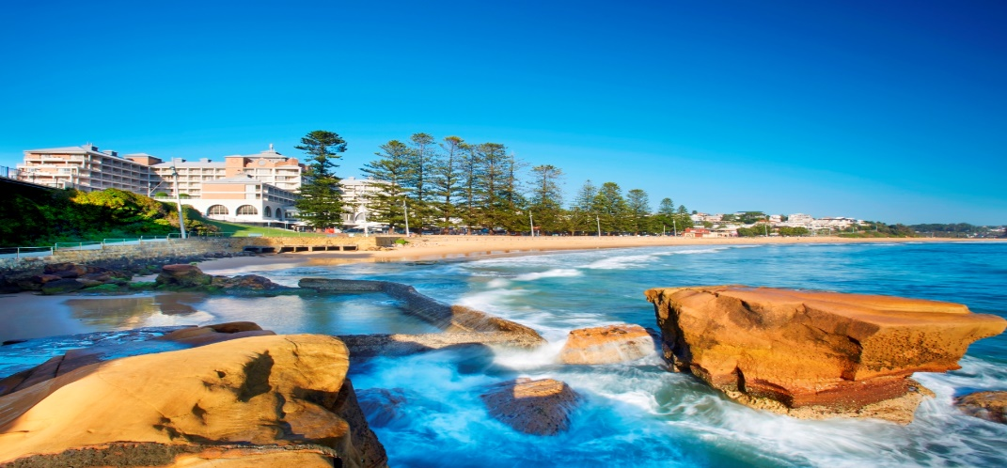
CROWNE PLAZA TERRIGAL – 14 TO 16 MAY 2021
DOES INDUSTRIAL RELATIONS REFORM HAVE A FUTURE?
DRAFT PROGRAM
FRIDAY 14 MAY 2021

REGISTRATION FROM 9:30AM OUTSIDE WAMBERAL ROOM. TEA AND COFFEE WILL BE AVAILABLE.
SESSION ONE
Session Chair | Jonathan Hamberger  President IRSNSW
9:50am  Conference Open and Welcome | Fiona Corbett  Australian Business Lawyers & Advisors - IRSNSW Conference Convenor | 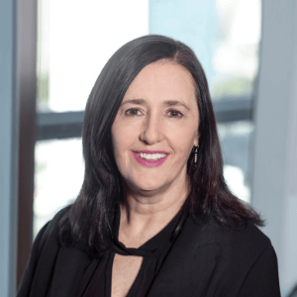

10am - 11:20am  The Future of the Award System | Stephen Smith  Head of National Workplace Relations Policy, Ai Group
Alison Pennington
Senior Economist, Centre for Future Work

Gerard Dwyer
National Secretary-Treasurer, Shop, Distributive and Allied Employee’s Association
11:20AM – 11:40AM - MORNING TEA OUTSIDE WAMBERAL ROOM
11:40am – 12:40pm  Commission Perspective | Commissioner Leigh Johns OAM  Fair Work Commission | 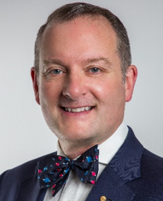
Commissioner John Murphy
Industrial Relations Commission of NSW

LUNCH 12:40PM - 1:40PM OUTSIDE WAMBERAL ROOM

SESSION TWO
Session Chair | Graham Evans  Managing Partner – O’Connell the Employment Law Specialists | 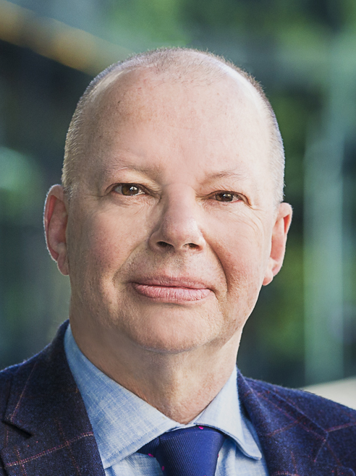
1:40pm - 3:00pm  The Future of Casual Employment | Luis Izzo  Managing Director – Sydney Workplace – Australian Business Lawyers & Advisors
 | Professor Mark Wooden  University of Melbourne | 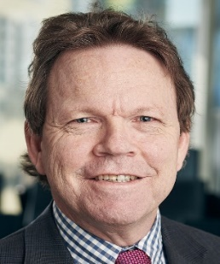
Thomas Costa
Assistant Secretary, Unions NSW
AFTERNOON TEA 3:00PM - 3:20PM OUTSIDE WAMBERAL ROOM

SESSION THREE
Session Chair | Sharlene Wellard  Principal – Meridian Lawyers
3:20pm - 4:40pm  The Future of Compliance and Enforcement | Dr Stephen Clibborn  Senior Lecturer – The University of Sydney Business School  Co-Director – Sydney Employment Relations Research Group (SERRG)
Natalie James
Partner, Workplace Integrity Risk Analytics, Deloitte Risk Advisory

Mark Morey
Secretary, Unions NSW
4.40pm-5.20pm  Political Update | Senator the Hon Amanda Stoker  Assistant Minister to the Attorney-General, Assistant Minister for Industrial Relations and Assistant Minister for Women
6:30PM Drinks Poolside

DINNER (CASUAL) 7PM SEASALT LOWER
Year in Review | Lucy Saunders  Barrister  Over drinks and dinner Lucy will remind us why we love industrial relations by reviewing the year that was, the legislation, the participants, the cases, the highs and the lows.

SATURDAY 15 MAY 2021
BREAKFAST FOR THOSE STAYING AT CROWNE PLAZA IN SEASALT FROM 6.30AM
SESSION FOUR
Session Chair | Julie Gordon  Industrial Lawyer, Flight Attendants’ Association of Australia |  | 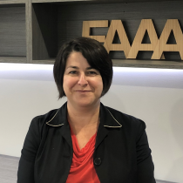
10am - 11:20am  The Future of Enterprise Bargaining | Scott Barklamb  Director, Workplace Relations, Australian Chamber of Commerce and Industry |  | 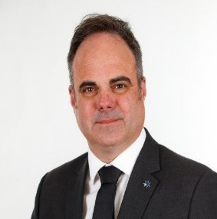
 | Professor Mark Bray  Newcastle Business School |  | 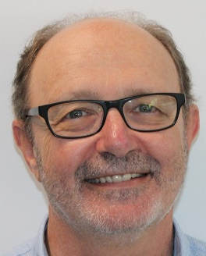
 | Alison Barnes  National President, National Tertiary Education Union |  | 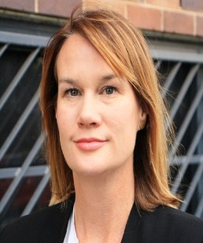
11:20AM - 12Noon MORNING TEA OUTSIDE WAMBERAL ROOM
12noon – 1pm  What are the Gaps in the Reform Agenda? | Discussion led by Jonathan Hamberger, President IRSNSW
 | John Counter, Consultant |  | 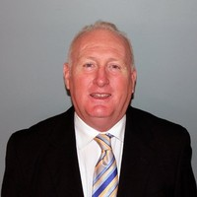
1PM CONFERENCE CLOSE
LUNCH 1PM SEASALT RESTAURANT
PRE DINNER DRINKS 6:30PM HAVEN TERRACE
DINNER (LOUNGE SUIT) 7PM HENRY KENDALL BALLROOM
Dinner Speaker |  | Deputy President Sams  Fair Work Commission |  | 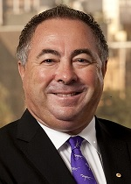
Entertainment |  | Matt McLaren  Matt's style seamlessly blends old-school classics with modern hits from a variety of genres including pop, rock, dance, blues and funk. |  | 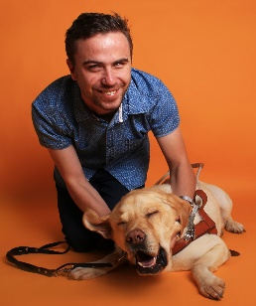
 |  | Please note that the program is subject to change

